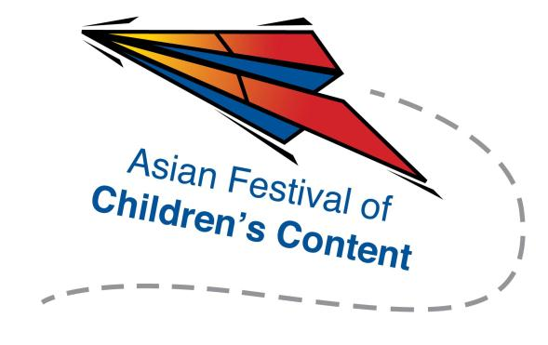
Speed Pitching (Writing)
17 May 2017 (Wednesday), 2.00pm – 4.15pm
The Pod, National Library Building

To register for a pitching slot, send this completed registration form and a screenshot of your AFCC Writers & Illustrators Conference ticket, to nurhuda@bookcouncil.sg by 14 April 2017.
Note: 1-Day Pass or 3-Day Pass ticket holders of AFCC Writers & Illustrators Conference are eligible for Speed Pitching (Writing). Selected applicants will be contacted via email.
Name: |  |  |  |  |  |  |  | Mr/Ms/Mrs/Dr
Address:
Tel: |  |  |  |  |  | Mobile:
Fax:
Email address:
Company/Organisation :
Designation:

Please underline the panellists you wish to pitch to (up to 2 names):
- Petra Nagyová Džerengová
- Andrea Pasion-Flores
- Lydia Leong
- Cynthea Liu
- Yong Shu Chiang

About your pitch
Please underline the format of your story:

- Picture book  - Middle-grade  - Young adult |  | - Comics  - Short stories  - Others; please specify: ________________
Please underline the genre of your story:

- Fantasy  - Horror  - Humour |  | - Romance  - Sci-fi  - Others; please specify: ________________
Target reader’s age:
Summary of your story (200-300 words):

Please briefly explain the appeal of your story (200-300 words):

Note: To ensure the smooth transition of the programme, we urge all selected participants not to hand over hard copies of manuscripts to the panellists. In the event that they are interested in your story, the panellists will ask for soft copies.

