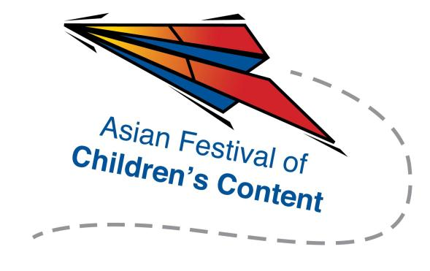
Speed Pitching (Media)
19 May 2017 (Friday), 2.00pm – 4.15pm
The Pod, National Library Building

To register for a pitching slot, send this completed registration form, together with a 300- to 500-word outline of your pitch, images of your proposed product and a screenshot of your AFCC Cross-Platform Summit ticket, to nurhuda@bookcouncil.sg by 14 April 2017.
Note: All selected applicants are required to attend “Pitch Perfect. The Ultimate Pitch-Ready Workshop!” with their pitches on 18 May, 2:00pm – 4:15pm prior to the Speed Pitching (Media) event. Selected applicants will be contacted via email.
Name: |  |  |  |  |  |  |  | Mr/Ms/Mrs/Dr
Address:
Tel: |  |  |  |  |  | Mobile:
Fax:
Email address:
Company/Organisation :
Designation:

Please underline the preferred panellists you wish to pitch to (up to 2 names):
- Justin Deimen
- Jyotirmoy Saha
- Leslie Lee
- Sanoop Luke
- Ryo Leong
- Karen Tang

