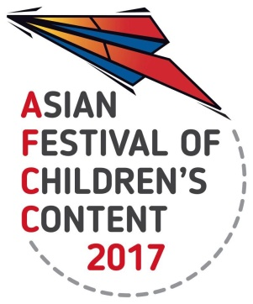
ASIAN FESTIVAL OF CHILDREN’S CONTENT
Asian Content for the World’s Children
17 – 21 May 2017 | National Library Building, Singapore

AFCC 2017 FIRST PAGES: Writing Critique
17 May 2017
Information Sheet

Kindly fill in all the fields below. If not applicable, indicate ‘NA’.
Send this Information sheet to judi@bookcouncil.sg by 2 May 2017.

Personal Details
Name:
Email address:
Current Country  of Residence: |  | Mobile/Telephone number:  (include country code)
Designation: |  | Organisation/  Company Name:

Your first page should be submitted with the template in page 2 and with these guidelines:
- In the top right-hand corner, list the genre (picture book, chapter book, middle-grade novel, young adult novel) and word count of the entire story.
- Type the title on the left of the page, below the genre and word count. The story of the first 100 words should follow.
- Use font size 11 and double line spacing format with margins be one inch all around.
- Please include an outline of your story (up to 40 words) in the Story Outline box.
- Please submit your formatted first page as a MS Word (.doc) attachment.
Story Outline
FIRST PAGES: SUBMISSION TEMPLATE

Genre:
Word Count:
Title of Book:
Title of Chapter:
If none, indicate ‘NA’

CONTENT
(100 words)

