**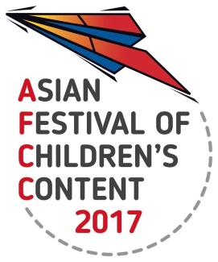  
ASIAN FESTIVAL OF CHILDREN’S CONTENT**

Asian Content for the World’s Children

17 – 21 May 2017 | National Library Building, Singapore

**AFCC 2017 FIRST LOOK: Illustration Critique**

**18 May 2017  
Information Sheet**

Kindly fill in **all** the fields below. If not applicable, indicate ‘NA’.   
Send this Information sheet and your illustrations to [judi@bookcouncil.sg](mailto:judi@bookcouncil.sg) by 2 May 2017.

|  |  |  |  |
| --- | --- | --- | --- |
| **Personal Details** | | | |
| **Name:** |  | | |
| **Email address:** |  | | |
| **Current Country of Residence:** |  | **Mobile/Telephone number:** *(include country code)* |  |
| **Designation:** |  | **Organisation/ Company Name:** |  |

|  |  |
| --- | --- |
| **First Look Submission Details** Format: Illustrations should be in jpeg format, resolution 72dpi, up to 1000px wide and 800px high. | |
| **Title of Book:** |  |
| **Description of the story:** *(up to three sentences)* |  |
| **Title of 1st Illustration:** |  |
| **Title of 2nd Illustration:** |  |
| **Title of 3rd Illustration:** |  |
| **Title of 4th Illustration:** |  |
| **Title of 5th Illustration:** |  |
| **Title of 6th Illustration:** |  |