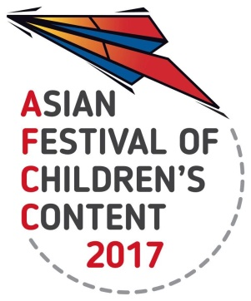
ASIAN FESTIVAL OF CHILDREN’S CONTENT
Asian Content for the World’s Children
17 - 21 May 2017 | National Library Building, Singapore

AFCC 2017 BOOK & PRODUCT LAUNCH SUBMISSIONS
INFORMATION SHEET

Name of Applicant |  |  | Please circle/highlight where appropriate  (1) AFCC Speaker  (2) Book Fair Exhibitor  (3) Delegate with 3-Day Writers & Illustrators Conference or Full Festival Pass
Title of book to be launched
Name of Author(s) & Illustrator |  |  | Nationality
Publisher |  |  | Year of publication of book
Address of Publisher / Applicant
Email Address |  | Contact Number
40-word synopsis of the book / product to be launched

Any other details | Please provide any additional information; planned promotion, activity during the launch, expected turnout or special technical requirements, which may help in our selection and allocation of venue.
Checklist | a) High resolution image of the book cover of at least 300dpi. Please attach as a separate JPEG/TIFF/PNG file to your submission.  b) Hard copy of the book. Please send a hard copy of the book to the following address:  National Book Development Council of Singapore  Geylang East Public Library  50 Geylang East Avenue 1  Singapore 389777

