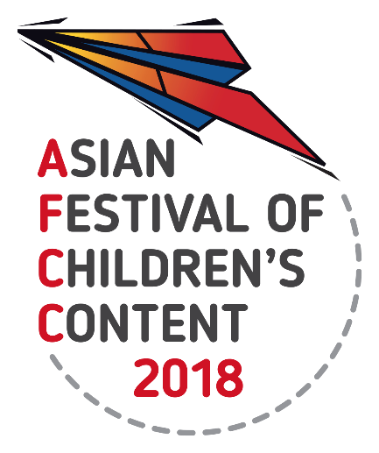
5 – 9 Sep 2018 | National Library Building, Singapore

AFCC 2018 CALL FOR PAPERS
Information Sheet

Thank you for your interest in speaking at our Festival. If you are selected you will receive a complimentary AFCC Full Festival pass (worth S$500), which includes admission to the Writers & Illustrators Conference, Cross-Platform Summit, Teachers Congress, and Parents Forum. Kindly note that the Full Festival pass excludes tickets for Masterclasses. Kindly note that honorarium, flight, and hotel accommodation is not included if you are selected as a speaker for the Asian Festival of Children’s Content (AFCC).

Please complete the Information Sheet and send this to Alycia Teo at alycia@bookcouncil.sg by
15 September 2017. Please complete all segments marked with the symbol ‘*’.

*Name |  | *Sex | Male ☐ Female ☐
*Country of Origin |  | *Current Country you are based in
*Designation  E.g. Author, illustrator, etc. |  | *Organisa-tion
*Mobile number  Please include the country code. | Kindly include your number, as it is for internal reference and will not be published for the public. | *Email address
Conference you would like to speak at
*50-Word Biography
If you are selected, this biography will be included on the AFCC website.
How did you find out about the Festival?
*First Topic | Title:
 | Description of presentation (200 word limit):
 | Synopsis (30 word limit). If you are selected, this synopsis will be used for the website and programme booklet:
Target Audience. Please select the appropriate target audience for your session:

Producers ☐ Screenwriters ☐ App developers ☐ Animators ☐ Filmmakers ☐ Authors ☐ Illustrators ☐ Publishers ☐ Teachers ☐ Parents ☐

Others (please specify): Click here to enter text.
Age group of children. Please select the appropriate age group of children that the content of your presentation is applicable to:

1 – 3 years old ☐ 4- 6 years old ☐ 7 - 9 years old ☐ 10 - 12 years old ☐
All of the above ☐

3 Take-away Points for Audience:
1.
2.
3.
Second Topic (optional) | Title:
 | Description of presentation (200 word limit):
 | Synopsis (30 word limit). If you are selected, this synopsis will be used for the website and programme booklet:
Target Audience. Please select the appropriate target audience for your session:

Producers ☐ Screenwriters ☐ App developers ☐ Animators ☐ Filmmakers ☐ Authors ☐ Illustrators ☐ Publishers ☐ Teachers ☐ Parents ☐
Others (please specify): Click here to enter text.
Age group of children. Please select the appropriate age group of children that the content of your presentation is applicable to:

1 – 3 years old ☐ 4- 6 years old ☐ 7 - 9 years old ☐ 10 - 12 years old ☐
All of the above ☐

3 Take-away Points for Audience:
1.
2.
3.
Third Topic (optional) | Title:
 | Description of presentation (200 word limit):
 | Synopsis (30 word limit). If you are selected, this synopsis will be used for the website and programme booklet:
Target Audience. Please select the appropriate target audience for your session:

Producers ☐ Screenwriters ☐ App developers ☐ Animators ☐ Filmmakers ☐ Authors ☐ Illustrators ☐ Publishers ☐ Teachers ☐ Parents ☐
Others (please specify): Click here to enter text.
Age group of children. Please select the appropriate age group of children that the content of your presentation is applicable to:

1 – 3 years old ☐ 4- 6 years old ☐ 7 - 9 years old ☐ 10 - 12 years old ☐
All of the above ☐

3 Take-away Points for Audience:
1.
2.
3.
Affiliations

Published Works
Include date of publication

*Checklist | Photo. Please attach your photo as a separate JPEG/PNG file to your submission in high resolution of at least 1MB, in colour.
*I have read the AFCC 2018 Call for Paper Guidelines which has been uploaded on the AFCC website.

____________________________________________________
Signature of Applicant/ Date

