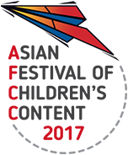
AFCC 2017 Rights Exchange
Registration Form
18 May 2017, 9am – 1pm | Level 16 The Pod, National Library, Singapore

To be listed as an AFCC RX participant, please fill up this form and send it together with a screenshot of your AFCC Ticket/Book Fair Confirmation Letter to carlo@bookcouncil.sg. Applicants will be contacted via email. Deadline of Application to be included in the roster is 15 March 2017.
Name |  | Mr/Ms/Mrs/Dr
Company/Organisation
Company Address
Tel No / Fax No | Mobile No
Email Address | Designation

COMPANY/AUTHOR PROFILE

