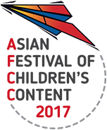
AFCC 2017 Rights Exchange | Meeting Form
18 May 2017, 9am – 1pm | Level 16 The Pod. National Library, Singapore

Name |  | Mr/Ms/Mrs/Dr
Company/Organisation | Designation
Email Address | Company Website

WRITE THE NAME/PUBLISHER whom you wish to meet (maximum four) at which timing block. Please be reminded that schedules are on a first-come-first-reserved basis. There is a possibility that the person you wish to meet is unavailable for the timing requested:

NAME | 9.00am-9.30am | 9.30am-10.00am | 10.00am-10.30am | 10.30am-11.00am | 11.00am-11.30am | 11.30am-12.00nn | 12.00nn-12.30pm | 12.30pm-1.00pm

