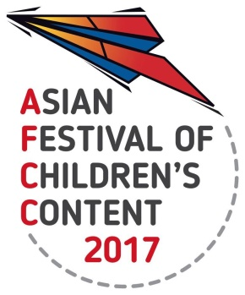
ASIAN FESTIVAL OF CHILDREN’S CONTENT
Asian Content for the World’s Children
17 – 21 May 2017 | National Library Building, Singapore
AFCC 2017 PORTFOLIO REVIEW
Information Sheet
19 May 2017
To register for a Portfolio Review session, please complete and send this form, together with a screenshot/attachment of your AFCC Writers & Illustrators Conference pass (3-day or 1-day) or AFCC Full Festival Pass, to judi@bookcouncil.sg by 2 May 2017. Each session will be 30 minutes in duration. You will be contacted with the session’s time by 16 May 2017.
Name: |  |  | Underline one:  Mr / Ms / Mrs / Dr
Current Country of Residence:
Mobile / Telephone number:
(include country code)
Email address:
Company/Organisation: |  | Designation in Company/Organisation:
Type of illustration:
(eg graphic design, watercolour, painting, comics)

Portfolio Review Panel: Each participant will only be able to consult one illustrator in the panel. Please type ‘1’ in the first column to indicate your first choice, and type ‘2’ to indicate your second choice. We will try to accommodate your requests, but the panellist you are assigned to is given on a first-come-first-served basis.
Panellist
- Briony Stewart (Australia)
skills: pencil, watercolour, ink and gouache on paper. Whimsical with a focus on characters, particularly children and animals
- David Liew (Singapore)
skills: Children's illustration and writing, whimsical illustration for chapter books and picture books, traditional and digital media.
- James Mayhew (UK)
skills: pen-and-ink with watercolour; gouache; mixed-media with household paints and pastels pencils, print-making and collage,
- Orit Bergman (Israel)
skills: picture book illustration, YA illustration, black and white
- PJ Lynch (Ireland)
skills: book illustration in watercolour and gouache paintings; charcoal and chalk drawings.

