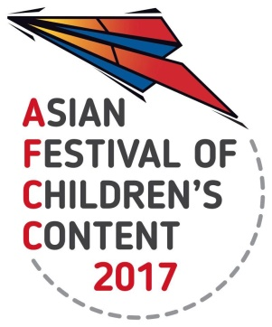
ASIAN FESTIVAL OF CHILDREN’S CONTENT
Asian Content for the World’s Children
17 - 21 May 2017 | National Library Building, Singapore

AFCC 2017 MAKAN & MINGLE SHOWCASE
INFORMATION SHEET

Name of Applicant
Title of book/ film/ app/ game
Name of Author(s) & Illustrator |  |  | Nationality
40-word bio of creator/s
Publisher/ Company |  |  | Year of publication of book/ film/ app/ game
ISBN Number of Book | Only relevant if you are submitting a book.
Address of Publisher / Company/ Applicant
Creator Email |  | Creator Contact Number
40-word synopsis of the book / film/ app

Website | If there is a website with more information about the book/ film/ app/ game, please type it here.
Checklist | a) High resolution image of the book cover/ product of at least 300dpi. Please attach as a separate JPEG/TIFF/PNG file to your submission.  National Book Development Council of Singapore  Geylang East Public Library  50 Geylang East Avenue 1  Singapore 389777

