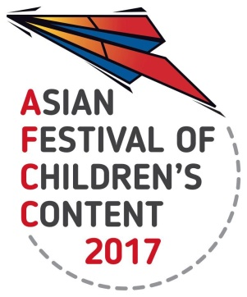

**ASIAN FESTIVAL OF CHILDREN’S CONTENT**

Asian Content for the World’s Children   
17 - 21 May 2017 | National Library Building, Singapore

**Celebrating Our Stars (17 May 2017) Showcase Info Sheet**

|  |  |  |  |  |
| --- | --- | --- | --- | --- |
| **Name of Delegate** |  | | | |
| **Title of book** |  | | | |
| **Name of Author(s) & Illustrator(s)** |  | **Nationality** |  | |
| **Author Email** |  | **Contact Number** |  | |
| **40-word bio of author(s)** |  | | | |
| **Publisher/ Company** |  | **Year of publication of book** | |  |
| **ISBN Number of Book** | *Only relevant if you are submitting a book and want to sell at Celebrating our Stars. There will be a bookstore featuring the showcased titles for sale.* **ISBN:** | | | |
| **Address of Publisher / Company/ Delegate** |  | | | |
| **40-word synopsis of book** |  | | | |
| **Website  (about the book)** |  | | | |
| **Checklist** | **a)** High resolution image of the book cover of at least 300dpi. Please attach as a separate JPEG/TIFF/PNG file to your submission.  **b)** Email completed Info sheet to judi@bookcouncil.sg by 26 April 2017.Attach to email your 1-day or 3-day Writers and Illustrators Conference ticket pass or Full Festival pass with your completed Info Sheet.  **c)** For delegates based in Singapore, to send the physical book by 12 May 2017. For delegates coming to Singapore, do leave your book on 17 May at the AFCC Registration desk into a box labelled ‘Celebrating our Stars Showcase’. Mailing address: National Book Development Council of Singapore  50 Geylang East Avenue 1, Singapore 389777 | | | |