Folklore Finesse

Retelling and Synthesis of Contemporary or Original Stories

By Tutu Dutta

AFCC 2017

FOLKLORE FINESSE

Q: How to incorporate folklore into the plot of your original story? Or use a storyline from an ancient folktale and turn it into a contemporary story?

An analysis of a number of books, indicate there are four different ways of using folktales in fiction:

- (Not so) Straightforward Re-telling of folktales
This is a time honoured tradition among story-tellers and writers – collecting oral folktales from people in villages and countryside publishing them in written form. These writers became household names: Charles Perrault, the Brothers Grimm, Hans Christian Anderson and more recently Jane Yolen and Angela Carter.
Experts believe these are not mere compilations but have been retold and edited by the authors.
Why is it necessary to retell folktales?
In their original forms:
*Stories are fragments i.e. some parts of the story is missing. A researcher in Sarawak told me that she found out one half of a story in one village and the other half in a different village. Research on folktales should not just focus on one particular folktale but also on similar stories and variants of the story. Reading a few versions of the same story will give you a feel for the story and help to fill in the missing pieces.

* Folktales lack descriptions – oral stories are usually pure narratives, with little
description of characters, time and place which form the backdrop to the story.
Details such as old place names, historical personages and cultural practices give
the book texture and context.

* Stories lack dialogues – contemporary readers expect a complete story with characters and dialogues

Example: Dragon Wells of Yanjing from Eight Treasures of the Dragon.
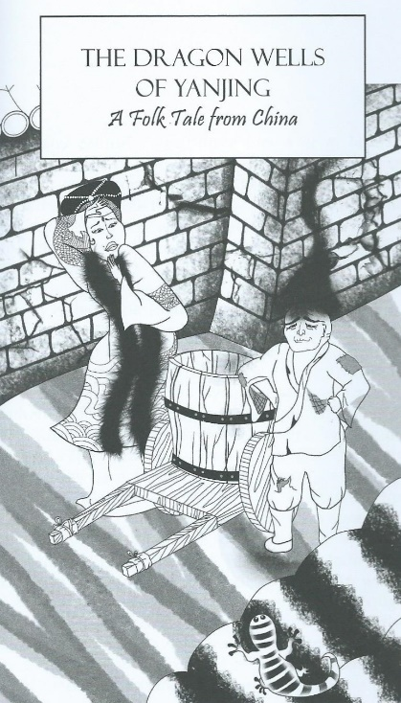
Illustration from Eight Treasures of
the Dragon by Tan Vay Fern

A folktale from China, Dragon Wells of Yanjing in Eight Treasures of the Dragon was based on the story of a Dragon king and queen who decided to punish the people of Yanjing (the old name of Beijing) for destroying their home when the city builders drained the lake which was their home. They avenged themselves by stealing all the water in the city wells.

In one version of the story, Kublai Khan was mentioned. So I decided to research the history of Beijing. I discovered that Kublai Khan did indeed re-design Yanjing. A huge lake was drained and a canal built to connect Yanjing with the South. That is the history; legend tells us that draining the lake had dire consequences for the people of Yanjing.

- Dressing Old Tales in New Clothes
In step 2, we take an old story and give it a modern look or interpretation, in effect dress old tales in new clothes. The plot remains the same.
Example: The Owl Service, (1967) by Alan Garner

This award-winning book relives an old legend dressed in modern clothes. The ancient Welsh legend is that of Lleu Llaw Gyffes, and his wife Blodeuwedd- a woman conjured from the essence of flowers by Lleu’s uncle, the wizard Gwydion. Later, she fell in love with Gronw Pebr, and together, they conspired to murder Lleu. Gronw mortally wounded Lleu with a spear but he escaped death by turning into an eagle and was saved by his uncle. Lleu demanded revenge and killed Gronw by throwing a spear with such force that it went through a rock behind which Gronw was hiding. For her part in her husband’s murder, Blodeuwedd was turned into an owl by Gwydion, a fate ‘worse than death’ we are told.
Garner’s book is about three teenagers who are thrown together by circumstance and became caught up in a love triangle. In The Owl Service, Alison is Bloduewedd, Gwyn is Lleu and Roger is Gronw. We learn that Gwyn’s ancient ancestors probably owned the valley even though his mother works as housekeeper for Alison’s mother and her stepfather, Clive Bradley (Roger’s father).

Slide 1: The Owl Service

Example: The Bloody Chamber by Angela Carter

This is a more contemporary re-telling of the story of Blue Beard. The plot is almost exactly the same as that in the dark fairy tale but the characters are early 20th Century with concerns and occupations closer to our time.

Slide 2: The Bloody Chamber
- Using a Quest/Journey to string together a series of folktales
Here, the story has an original plot i.e. a main story arc and the folktales occur as a series of ‘events’ or ‘adventures’ in the story. In some cases, the folktales are not entirely related to the main story arc.
Example: Where the Mountain Meets the Moon (2009) by Grace Lin

This story incorporates several well-known Chinese folktales as part of its plot.

In the main story arc, Minli, a little girl from an impoverished village located in a place called Fruitless Mountain Valley, goes on a quest to see the Old Man of the Moon in an attempt to change the fortune of her family and her village. A very traditional plot from folktales.
Along her journey she meets and befriends a friendly dragon who is unable to fly. The dragon itself is a character from a famous folktale – about a lifelike but unfinished painting of a dragon by a master painter which came to life when the painting was completed by someone else – by drawing in the dragon’s eyes. Minli and the Dragon decide to help one another – Minli in her quest for fortune which she believed will bring her family happiness and the Dragon in his quest for flight. Along their journey, they encounter several characters from Chinese folktales, who each have their own stories to tell.

Slide 3: Cover of Where the Mountain Meets the Moon

The second book, as in the case of the 1001 Nights/Arabian Nights, uses the device of a story teller to string together a series of folktales. At the same time, there is a main story arc which is independent of the folktales.

Example: Nik and the Secrets of the Sunset Ship (2016) by Ninot Aziz.

The main story arc is about Nik, a young and gifted sailor, who goes on holiday to a seaside resort in Terengganu to sort out his feelings. In this story arc is his resentment against his father for pushing him too hard to compete in the Olympics and his fear of failure. While on the beach one evening, he sees an ancient ship with dark sails and meets an old man, Pak Hitam, who tells him a series of old Malay folktales over a few nights. Nik relives these tales and comes to understand his feelings better. The folktales here are not as well integrated into the story as Grace Lin’s book.

Slide 4: Nik and the Secret of the Sunset Ships

- Weaving folktales into a new story strand
At this level, the folktales are not independent stories but become fully integrated into the main plot or story arc. The characters from folktales are fully fleshed out as protagonists and antagonists. In some cases, folktales form important sub-plots which form an important part of the main story arc.

Example: Court of Thorns and Roses by Sarah J Maas

The first book in the series is based on two fairy tales: Tam Lin (Scotland) and Beauty and the Beast (France).

In the Scottish folktale, Tam Lin is abducted by the Queen of the Fairies and turned into one of her knights/huntsmen whose job is to guard a forest grove. A young woman called Janet trespasses into the forest and plucks a rose, which summons Tam Lin. Janet falls in love with him. Tam Lin tells her that he will be sacrificed as the seventh year of his captivity is approaching. In the end, Janet saves him through her courage and tenacity.

In Court of Thorns and Roses, Tamlin is Lord of the Spring Court in the Fairy Realm. He takes a young woman called Feyre captive for killing a sacred wolf. She falls in love with him but later finds out that he is cursed by the Fairy Queen and she could have freed him by declaring her love. When he is taken captive by the Fairy Queen and she has to save him, through both a test of skill & strength as well as a test of brains i.e. solving a riddle.

Slide 5: Court of Thorns and Roses

Three books called the Chronicles of Old Japan by Australian author, Ruth Manley incorporate characters, ideas and storylines taken from Japanese folklore directly into her stories.
- The Plum Rain Scroll, 1978
- The Dragon Stone, 1982
- The Peony Lantern, 1987
In the first book has an original plot.

The Plum Rain Scroll is a magical scroll which is written in the ‘old language’ – an idea from folklore. It contains three great magic – the secret of immortality; the secret of turning base metal into gold and the ‘unanswerable word’. The main protagonist is an odd-job boy called Taro, a foundling who helped his Aunt Piety to run an Inn. Taro is thrown into the fray when the evil warlord, Lord Marishoten, and his Black Warriors attempted to capture Aunt Piety, she being the only person in the land who can still read the ‘old language’. Along the way to rescue his aunt, Taro meets up and form allegiances with a motley crew of friends and creatures from Japanese history and folklore.

Slide 6: Cover of new Plum Rain Scroll

The Dragon Stone – Another antagonist emerges in the second book. She is the Jewel Maid and it turns out that Lord Marishoten is actually her servant. The Jewel Maid is based on an old Japanese legend – that of Tamano, a beautiful and ancient nine-tailed fox demon. In folklore, Tamano bewitched the Emperor and sought to destroy the Imperial line until her true identity was discovered and she was driven out. She sought refuge in a black stone which came to be known as the Death Stone. In the book, the Dragon Stone has the power to bend the will of people.

Manley incorporated another iconic Japanese folktale, the Taketori Monogatari into this book. To summarise: A poor bamboo cutter finds a shining child (and nuggets of gold) in the stump of a large bamboo. He takes her home to his wife and they raise her as their own child. She is known as Kaguyahime and grows up into an accomplished and amazing beauty. Her five most illustrious suitors are each given an impossible task to win her hand.

In The Dragon Stone, Kaguyahime is sent to earth for the express purpose of locating the Dragon Stone to prevent it from falling into the hands of the Jewel Maid. As in the folktale, Otomo no Miyuki was given the task of obtaining the Dragon Stone (retold in my book, Eight Jewels of the Phoenix.) In this he succeeds but he falls under the stone’s influence and triggers off the Genpei Wars (a real historical event). It falls to Taro and friends to locate and unmake the Dragon Stone, again guided by a riddle.

Slide 7: The Dragon Stone

The Peony Lantern incorporates a several myths into its storyline. The title of the book refers to an eerie Japanese ghost story. A central subplot is the story of Ho-Wori and the Princess of the Sea (this is a myth I retold in my book ‘Eight Treasures of the Dragon’ as ‘Ho-Wori and the Princess of the Sea’). It is the story of two brothers Ho-Wori (Prince Fire Fade) and Ho-Deri (Prince Fire Flash) who are bitter rivals. One day, Ho-Wori gets lost at sea and is taken to the place of the Sea king. He falls in love with the sea king’s daughter and marries her. After some time, he is overcome with homesickness and decides to return home. He is given a treasure chest and two magical pearls as gifts by the sea king.

In the book, The Jewel Maid and Lord Marishoten re-emerge, but this time they are seeking the objects of power known as the windflowers. No one realised that the windflowers were actually the two pearls – the tide-ebbing and the tide-flowing pearls - which had been given to Ho-Wori by the sea king. Ruth Manley successfully incorporated this old myth into an integral part of the story.

Slide 8 – Peony Lantern

- Creating a Contemporary Story from Folktales
Here I explain further about incorporating elements of folktales to create an entirely new contemporary story, using Phoenix Song to explain how I came up with the plot:

When Alice Curry from Lantana Publishing (UK) contacted me about the possibility of writing a story for a children’s picture book, I immediately thought of the Malay folktale of Buluh Perindu.

Example: Pheonix Song

Phoenix song draws upon two separate folktales:

The first one is the Malay folktale of Buluh Perindu (literally yearning or sighing bamboo). The bamboo grove represents nature in the story. In traditional Malay culture, nature was so revered that a child is taught to ask for permission before even plucking a single flower. In the original story, three brothers were given the task of bringing back a bamboo cutting from a hill which was haunted or cursed. The two elder brothers ignored the advice of an old man they met on the way, and were turned to stone.

The story also referred to the old taboo not to respond or look back when one hears one's name being called in wild and lonely places... The youngest brother, who showed respect for the old man and followed his counsel, managed to obtain a piece of the magical buluh perindu. He fashioned a flute out of the bamboo and succeeded in reversing the curse on his brothers, just by playing the flute.

I came across the story of Buluh Perindu some years ago but felt that there was something missing, it felt like a fragment. Although the bamboo flute produced beautiful music, there were no other stories about its power to break curses; apart from Mozart’s The Magic Flute :)

Later, I came across the Chinese legend of the wild musician or scholarly woodsman who was such a supernaturally gifted musician, he could tame wild animals and even summon the phoenix whenever he played the xiao (a Chinese bamboo flute). If any magical creature could break a curse, it would be the phoenix. In addition, there were other East Asian folktales linking the music of the bamboo flute to the phoenix. In one, a phoenix appears to advise a pining Persian king to make a bamboo flute in order to win the heart of a Chinese princess…

The two stories seemed to fit because they both involved a bamboo flute and the magic of music… The phoenix in our story is Cendrawasih or Fenghuang, a symbol of Spring, longevity and the renewal of life.

The story lent itself easily to a contemporary setting, with younger characters and the focus shifting to family and sibling rivalry. To make the story even more immediate, the narrative is told in a series of dialogues, between Arohan and his extended family and sometimes with himself. The book also serves to remind us of the deep reverence (and fear) for nature, we once had...

Slide 9: Phoenix Song and Lagu Cenderawasih

Example 2: The Jugra Chronicles.

*Miyah and the Forest Demon (2011)
*Rigih and the Witch of Moon Lake (2013)

First of all decide on a setting for your story – the place and time. When writing a story set in this part of the world it is always wise to consider the two main trade routes of the past – the overland Silk Route and the sea bound Spice Route. As we are right in the midst of the Spice Route (The so-called Spice Islands have identified as the Moluccas), it is natural to think of the Spice Trade.

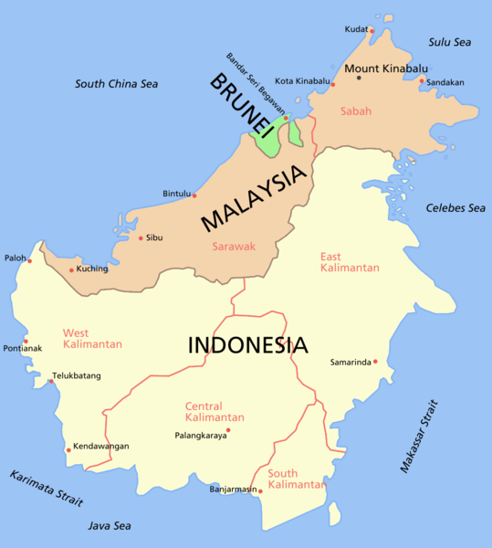
Map of Borneo
I chose to set the story in Borneo, due to the unique and diverse folklore traditions associated with the island – including head-hunting and the use of magic. In the end, I narrowed it down to a coastal region near Brunei - in the past, the Sultan of Brunei had suzerainty over most of Borneo – and also because the two Malaysian states of Sabah and Sarawak meets with Brunei and Indonesian Kalimantan here.

The time period is the 17th Century – over a hundred years after the fall of the Melaka Empire. I did some research on the history of the area and came across the name ‘Tanjungpura’ and decided to use it in my story. The story is set against the backdrop of a power struggle in Tanjungpura, an ancient trading with ties to the Han Kingdom (China), Hindustan (India), Majapahit (Indonesia) and Melaka (Malaysia) – which is now under the Dutch.
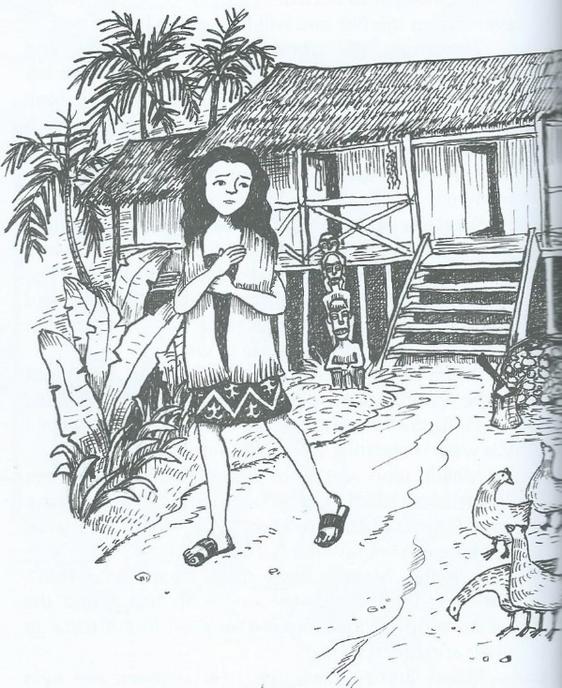
Illustration from Miyah and the Forest Demon
by Choong Kwee Kim
The protagonist is a girl called Miyah, whose father is the village Shaman. Her best friend is Suru, a girl whose father (a spice trader from the Han Kingdom who fell ill and was left behind and became stranded in the village) has long since left the village. Miyah’s mother is the village mid-wife, a role which is also associated with magical abilities.

