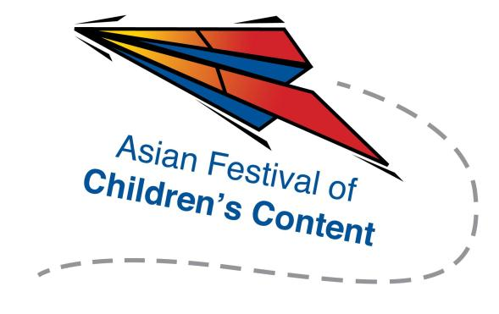
Speed Pitching (Writing)
25 May 2016 (Wednesday), 2.00pm – 4.15pm
The Pod, National Library Building

To register for a pitching slot, send this completed registration form, together with a 1-paragraph outline of your pitch and a screenshot of your AFCC Writers & Illustrators Conference ticket, to mabel@bookcouncil.sg by
18 April 2016.
Selected applicants will be contacted via email.
Name: |  |  |  |  |  |  |  | Mr/Ms/Mrs/Dr
Address:
Tel: |  |  |  |  |  | Mobile:
Fax:
Email address:
Company/Organisation :
Designation:

Please underline the panellists you wish to pitch to (up to 2 names):
- Andrea Pasion-Flores
- Sarah Odedina
- Daphne Lee
- Kajiya Bunsho
- Eliza Teoh
- Cynthea Liu

