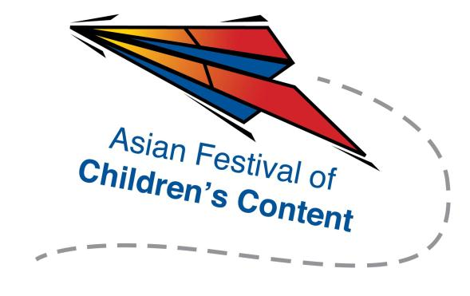
Speed Pitching (Writing) Registration Form
AFCC Writers & Illustrators Conference
4 June 2015 | National Library Building, Singapore | 1.30pm – 2.45pm

To register for a pitching slot, please fill up this form, together with a screenshot of your AFCC Writers & Illustrators Conference Ticket (either 1-day ticket or 3-day pass), and send them to mabel@bookcouncil.sg by 18 May 2015.
Selected applicants will be notified via email.
Name: |  | ___________________________________________ |  |  |  |  |  | Mr/Ms/Mrs/Dr
Address: |  |  | _________________________________________________________
_________________________________________________________________
Tel: | ___________________________ |  |  |  |  | Mobile: | _______________________
Fax: | _______________________________________
Email address: |  |  |  | _____________________________________________________
Company/Organisation : |  |  |  |  | _______________________________________
Designation: |  |  |  |  | _______________________________________

One-paragraph outline of your pitch (150 words or less)
____________________________________________________________________________________________________________________________________________________________________________________________________________________________________________________________________________________________________________________________________________________
Please underline whom you wish to pitch to (maximum two):
- Andrea Pasion-Flores
- Edmund Wee
- Tina Narang
- Zhao Wuping (primarily Chinese stories)
- Chan Wai Han

