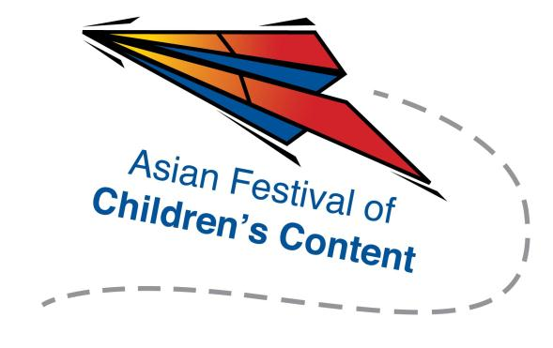
Speed Pitching (Media) Registration Form
AFCC Media Summit
5 June 2015 | National Library Building, Singapore | 1.30pm – 2.45pm

To register for a pitching slot, please fill up this form, together with a screenshot of your AFCC Media Summit Ticket to mabel@bookcouncil.sg by 18 May 2015.
Selected applicants will be notified via email.
Name: |  | __________________________________________ |  |  |  |  |  | Mr/Ms/Mrs/Dr
Address: |  |  | _________________________________________________________
__________________________________________________________________________________
Tel: | __________________________________ |  |  |  |  | Mobile: | _______________________
Fax: | ___________________________________
Email address: |  |  |  | _____________________________________________________
Company/Organisation : |  |  |  |  | _______________________________________
Designation: |  |  |  |  | _______________________________________
One-paragraph outline of your pitch (150 words or less)

____________________________________________________________________________________________________________________________________________________________________________________________________________________________________________________________________________________________________________________________________________________________________________

Please underline whom you wish to pitch to (maximum two):
- Alison Norrington
- Marco Sparmberg
- Eric Huang
- Saad Chinoy
- Raymond Tan

