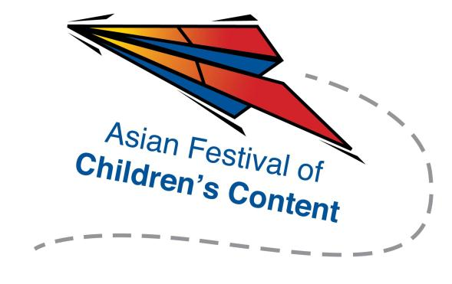
AFCC Media Summit 2014
Speed Pitching (Writers) Registration Form
3 June 2014 | National Library, Singapore | 4.00pm – 5.30pm

To register for a pitching slot, please fill up this form and send it together with a one paragraph outline of your pitch and a screenshot of your AFCC Ticket to stephanie@bookcouncil.sg.
Selected applicants will be contacted via email.
Name: |  |  |  |  |  |  |  | Mr/Ms/Mrs/Dr
Address:
Tel: |  |  |  |  |  | Mobile:
Fax:
Email address:
Company/Organisation :
Designation:

Please underline whom you wish to pitch to (maximum three):
- Stacy Whitman
- Linda Tan Lingard
- Sayoni Basu
- Frances Plumpton
- Edmund Wee
- Daphne Lee

